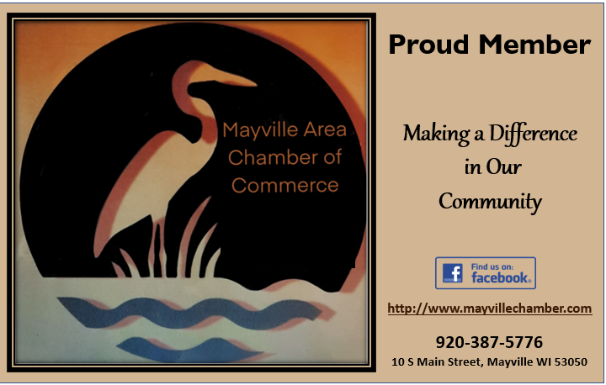  Mayville Chamber of commerce  May 2021  The Chamber of Commerce in conjunction with the Mayville High School Art instructor Sarah Heideman, held a logo contest as part of a commercial design assignment. Sophomore Natalie Ganiere’s design is a part of our new membership window stickers!  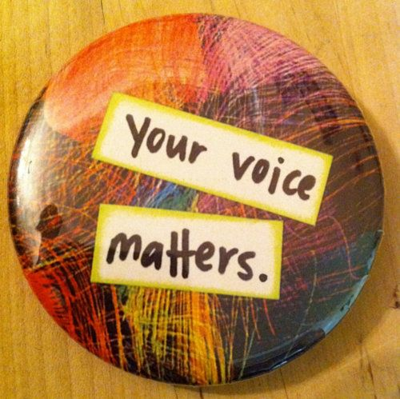  Thank you for your feedback!  We received numerous positive responses from members about a joint partnership with Horicon Chamber of Commerce. We are forming a committee to continue discussions on this important topic. Interested in joining the committee? | Chamber $500 Cash Raffle- Purchase from your Chamber Board or at 10 S Main Street  _____  SAVE THE DATE!  Chamber Golf Outing Friday August 27th  More info to come  ────  Rock n’Boom Set for July 3rd. The Chamber will be selling concessions  ────  Concerts in the Park every Thursday in June.  The Chamber will be selling burgers on June 3rd for 1-man Band -Mark Croft  ────  Next Board Meeting May 10th 2021 in the Chamber office  10 S MAIN ST.

Volunteering to make

A

Better Mayville!
We would love your help selling Raffle Tickets, Rock n’ Boom concessions, or Hamburgers
at our Concert in the Park!
Give Dawn a call at the # below if you have a few hours to donate.
Chamber- Make it Mayville Community Guide
We are finishing up on the Community Guide! Available in June!
Sneak Peek- picture shown is the new cover for 2021-2022!
This will be a great tool for the community and Tourists alike! Let Dawn know if you can display them in your business.

President- Christopher Neu, Sidelines
Vice President, Stephanie Albers, Horicon Bank
Treasurer- Kate Larson, TSB Bank
Board Members
Curt Schmidt, Piggly Wiggly
George Neu, The Tinker Shoppe
Jessica Schantzen, Mayville Savings Bank
Administration
Dawn Gindt 262-224-2947
Would you like to Join the Chamber Board?

your Chamber Board
Web Watch

www.mayvillechamber.com
is currently under construction! Watch for exciting new programs, announcements, community calendar and more!

CHAMBER RAFFLE The $500 cash Raffle Tickets are available!
$5 each or 3 for $10.
Drawing will be June 1st


